Customer has lost connectivity after security setup

Assumptions
Customer has connection via wireless.

Determining the problem
Scan networks or “view available wireless network” to see if you can see the connection name (by default it is ConnectionPoint). Common problems are:

Problem 1
No Connection available.

Solutions
1. User might not have their wireless card turned on (for laptops or built-in wireless card). Turn it back on.

2. Check WLAN is on.

Problem 2

If the ‘connection name’ is not in the list

Solution 1
Customer might have SSID broadcast off. Please switch it back on.

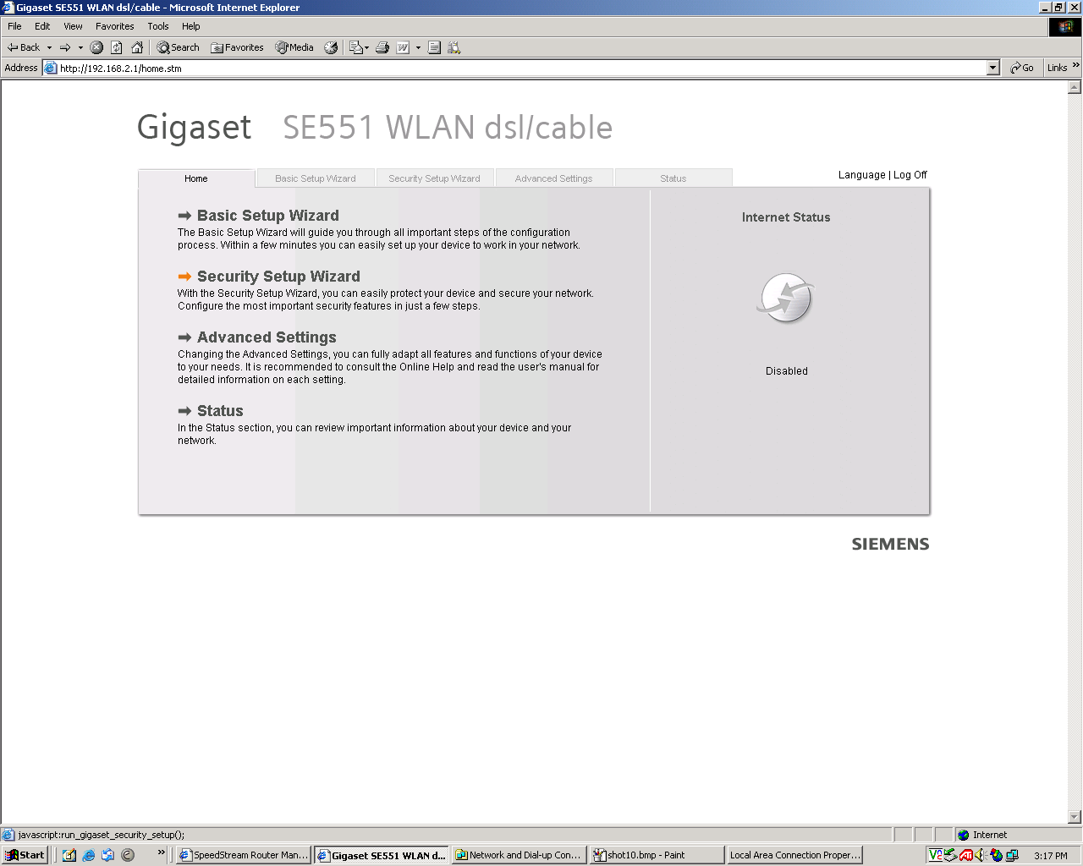
Go to the security setting:

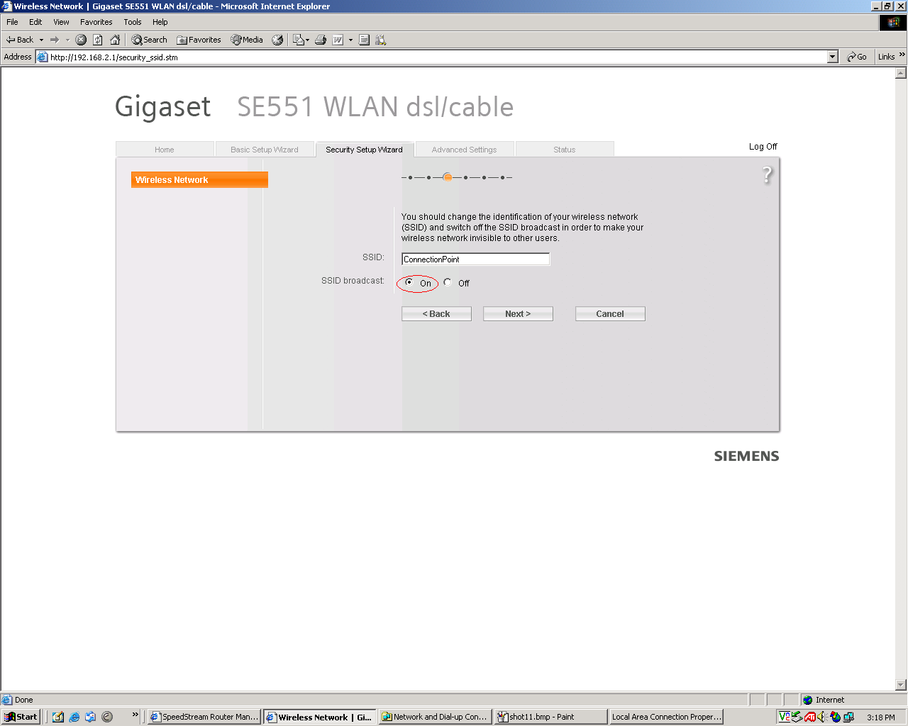

Turn the SSID broadcast on.

Problem 3
Found the connection but when entered the key, an error message would display something like “the network password needs to be 40 bits…..”

It may take too long to connect without errors or nothing happens.

Solution

Customer might have set up the security as WPA2-PSK which the wireless adapter driver does not support, or Windows does not support. Either upgrade to Service Pack 2 or upgrade the driver, or change it to another security type (WEP or WPA-PSK)

Step 1

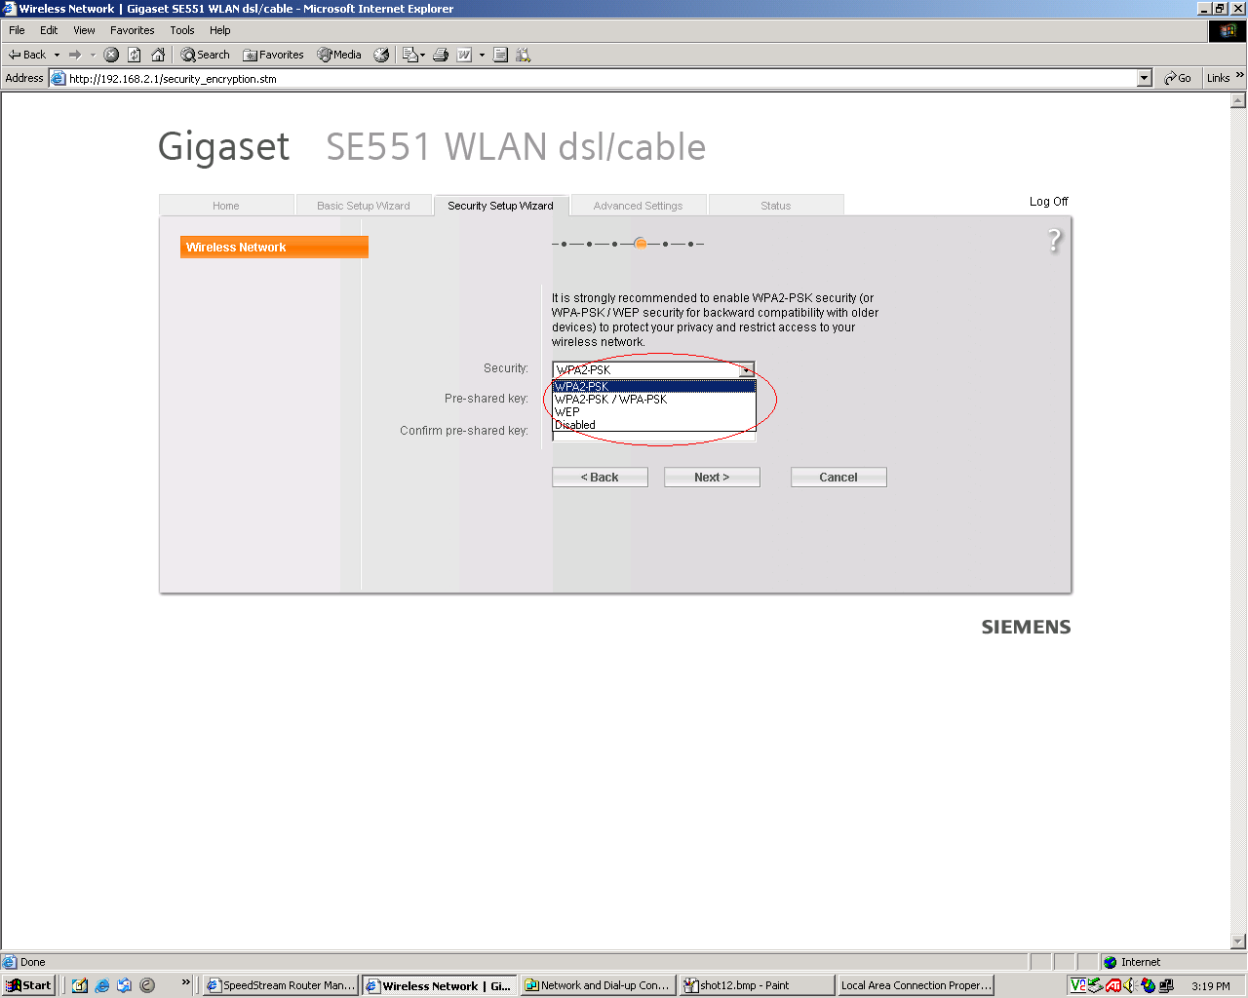
Go to the security settings and then change the security type as shown above and proceed to ‘Next’ to finish.

Step 2
If you still cannot connect to the wireless connection, then Windows configured itself for the changes

Go to “Start” → “Setting”→”Control Panel”→”Network Connections”

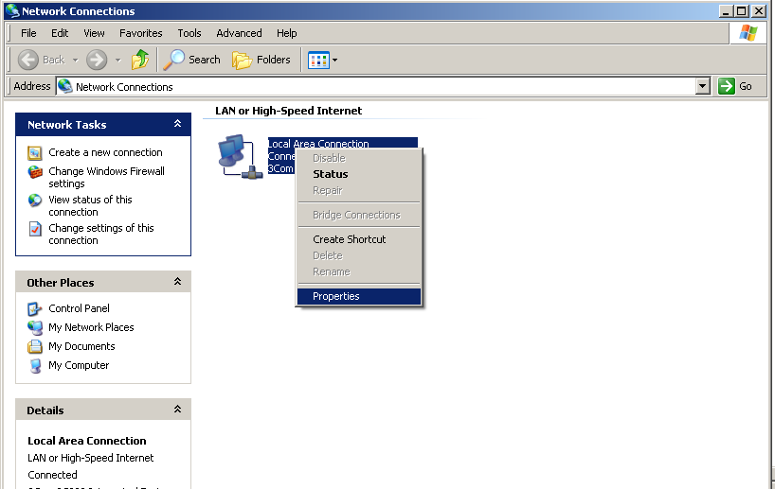
Right click on “Wireless Network Connection” and click properties.

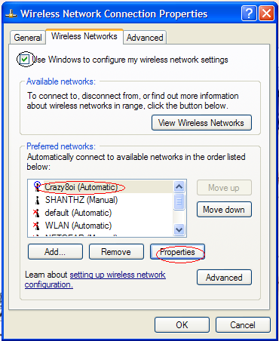

Tick the box “Use windows to configure my wireless network settings” and select the “Connection Point” or the name that you have called it, then click on properties.

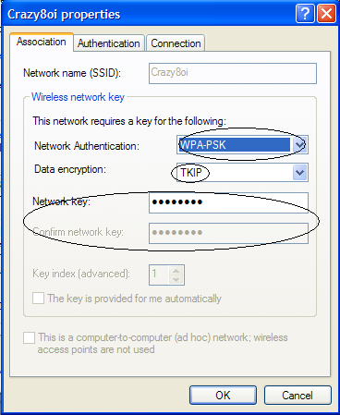

Change the settings as shown above to be the same as the router.

For example, if you have changed it to WEP from “Network Authentication”, select “WEP”, then enter the key into it, click ok.

If the security is WPA-PSK then the “data encryption” should be TKIP, or if the security is WPA2-PSK then the “data encryption” should be “AES”

Problem 4
When trying to view wireless connections, a message appears “Windows cannot configure this wireless connection. If you have enabled another program to manage this wireless connection”

Solutions
Right click on wireless network connection and click properties
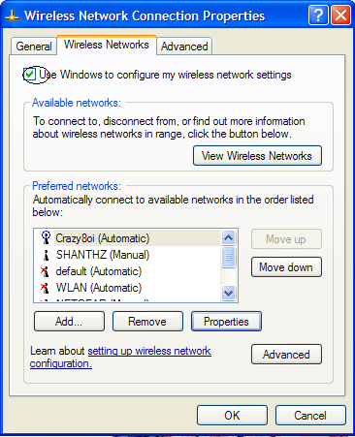

Tick box “Use window to configure wireless connection” and confirm with ‘OK’

Page cannot be displayed
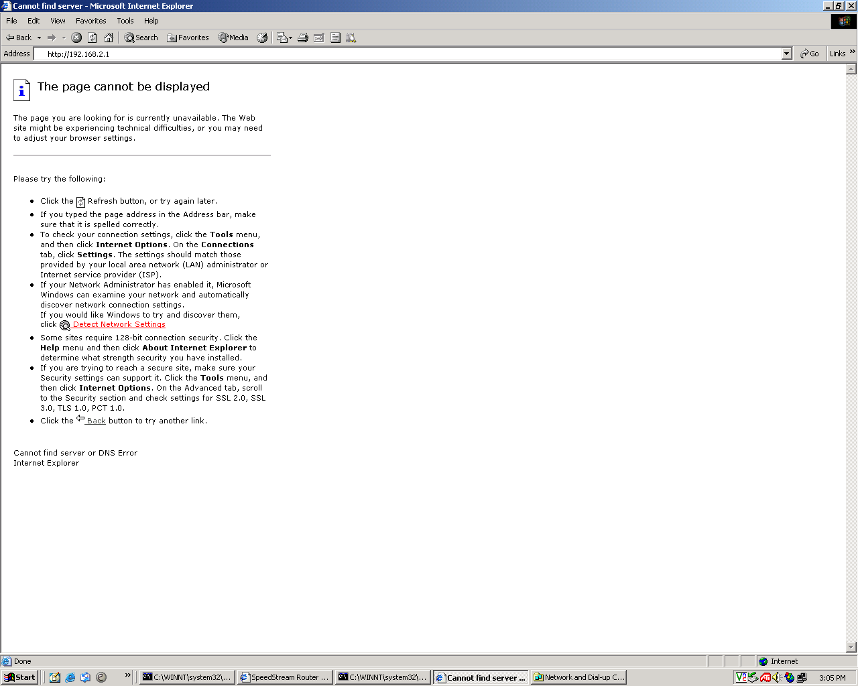

If all cabling is correct, but you still cannot go into the homepage address of 192.168.2.1. Follow the steps below to determine and resolve the problem

Step 1

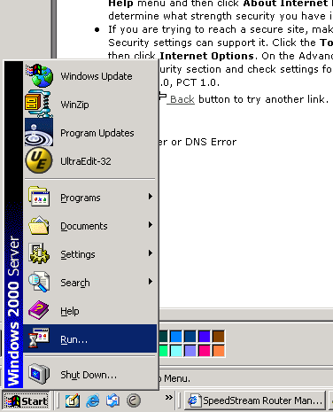

Go to start → run

Step 2

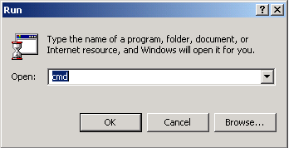

Type “cmd” and hit “OK”

Step 3

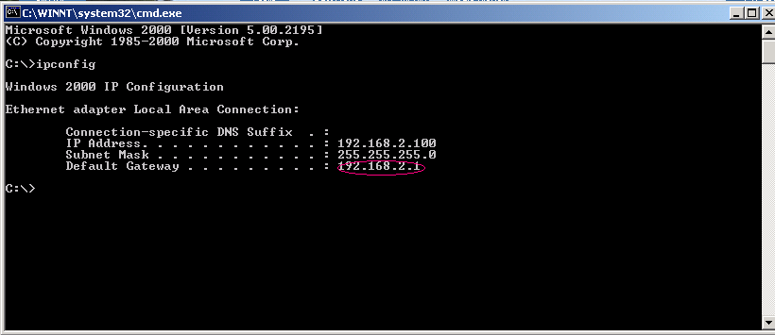

The marked IP address should be there, but if the default gateway is empty then proceed to steps 4-7

Step 4
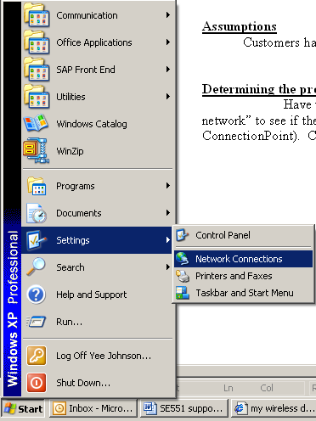

Go to ‘Settings’ → ‘Network Connections’

Step 5

Right click on the “Connection” and then select properties
Step 6
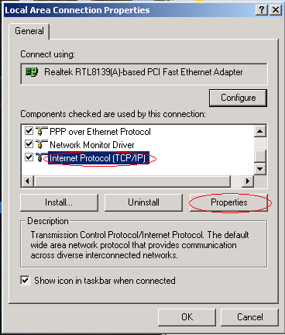

Click once on “Internet Protocol (TCP/IP) to highlight, then select on “Properties”

Step 7
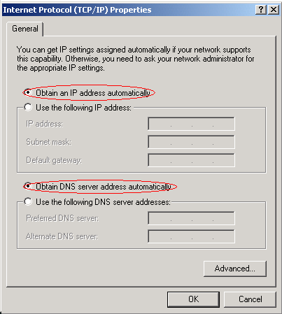

Select the “Obtain an IP address automatically” and “Obtain DNS server address automatically”

After this repeat steps 1 – 3, to make sure that the default gateway address is there. If not then restart the computer.

Connection have limited or no connectivity

Check cabling. Disable the connection, then switch off every including the router, modem and wait for a while. Then turn it all back on and enable the connection again.

IP Conflict

Make sure all the cables are properly connected. If you are using the router via ethernet cable, then there must be no USB cable going from the modem to the router. Unplug the USB cable.

SE551 Security Setup

Go to security setup

In this page, switch the SSID broadcast “ON”

In this page, chose “WPA2-PSK” if you are using the Siemens UBS wireless stick.

If you are using a built in wireless card, then select “WPA2-PSK/WPA-PSK” or “WEP” (for older computers)

Then enter the network key. (It must be at least 8 characters long for “WPA2-PSK” and “WPA2-PSK/WPA-PSK”).

IF WEP is chosen, then enter the following fields:

=================================================
Security type = WEP

Key length = 128bits

Input type = KEY

Key type = ASCII

Key = ****************** (Make up a key exactly 13 characters long)

Confirm Key = ********************
==================================================

Then click next, leave Mac Filter “OFF” then select finish

After the router has finished booting up, then select “Log off” on this page. Unplug the cable and follow the steps below:

Step 1

Go to → start→settings→control→network connections

A similar screen will appear

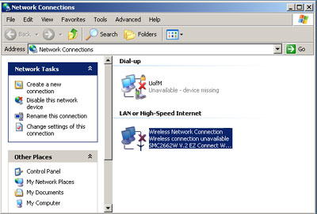

Step 2

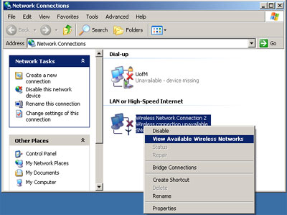

Right click on wireless network connections, then select “View available Wireless networks”

A list of available wireless network will be shown. Select your own wireless connection and click connect.

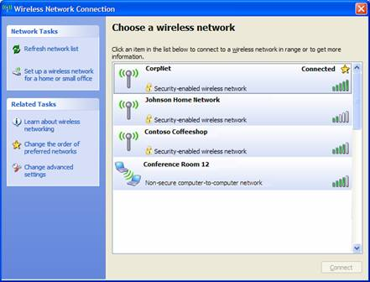

If you still cannot connect to the wireless connection, then Windows has not configured itself for the changes.

Go to “Start” → “Setting”→”Control Panel”→”Network Connections”

Right click on “Wireless Network Connection” and select ‘Properties’.

Tick the box “Use windows to configure my wireless network settings” and select the “Connection Point” or the name that you have called it, then click on properties.

Change the settings as shown above, they must be the same as the router.

For example, if you have changed it to WEP from “Network Authentication”, select “WEP”, then enter the key into it, click ok.

If the security is WPA-PSK then the “data encryption” should be TKIP, or if the security is WPA2-PSK then the “data encryption” should be “AES”

